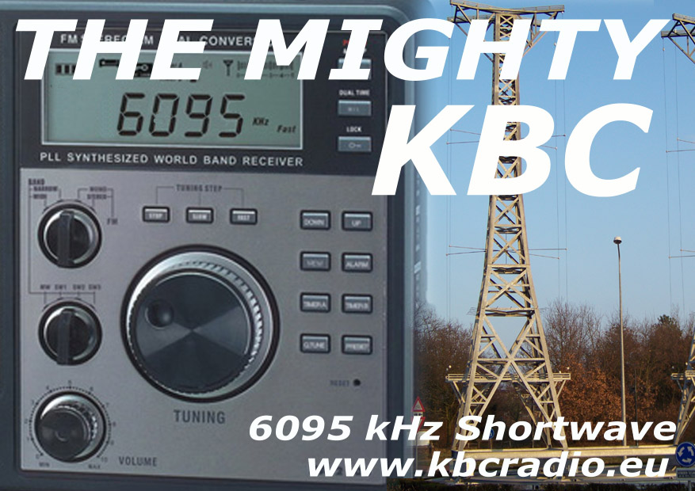

We are happy to confirm that the transmission you heard on:
9400 kHz
Date: 7 / October / 2012
Time: 00.00 - 00.27 UTC
Transmitter: 100kW
Is a Mighty KBC programme.
Thank you for getting in touch!
We hope you continue to enjoy our radio programmes.

For an original KBC QSL card by post
send 2 USD, or 2 IRC’s to:

KBC
Argonstraat 6, 6718 WT Ede, The Netherlands

The Mighty KBC QSL Card Is Sponsored By KBC Import / Export

